2023-2024



Starr’s Mill Theatre
Handbook

TABLE OF CONTENTS

Welcome, Mission and Vision

Contact Information

Personnel

Important Dates

Thespian Society Meetings

Georgia Thespian Conference

Season & Shows

Auditions

Rehearsals

Tech Week and Show Nights

Expectations and Rules

Discipline

Tickets

Georgia High School Musical Theatre Awards (Shulers)

Fees/Dues/Payments

Events and Field Trips

Sponsorships and Donors

Shout Outs and Ads (Receipt/Form)

Technical Theatre Permission Slip

Parent Booster Club (SMP)

Theatre Lingo

WELCOME, MISSION AND VISION

Welcome, Parents and Students to Starr’s Mill Theatre! We could not be more honored that you have chosen to join us. First and foremost, we exist to create life-changing artistic experiences for students and audience members alike. Additionally, we hope that as you leave us, you will have been given the tools necessary to be a successful theatre artist and human, at the collegiate level. Oh, and it is some of the most rewarding and fun work you will ever do! High school theatre is one of the most familial-like organizations on campus.
While we have a lot of laughs, and enjoy what we do, it cannot go without saying – theatre is hard. High school theatre is no longer as it was in the days of yesteryear. High school theatre has now moved into one of the most competitive, and sought after activities in the country. Meaning, we run our program much like a pre-professional program as we want our students to be prepared for the next level of theatre should they choose to pursue it. What does this mean? It means that we push ourselves and our students to present their very best creatively and professionally.
Studies show that students that participate in theatre programs are more well-rounded, more likely to come to school, more likely to be comfortable with speaking with others and much more. Here is a lovely article that summarizes all the reasons your child can benefit from theatre.
We strive to have a unified approach in all we do. From this day forward, if you are involved with SMHS Theatre, we ask that you ask yourself this question in all you do:

“Does this help fulfill our mission and vision?”

The creative staff here at SMHS Theatre most definitely will, and we ask that you as parents and students do the same.

Our Mission:
Starr’s Mill Theatre is dedicated to providing students with theatrical experiences, educational opportunities, and life-long skills that are uniquely ambitious, transformative and innovative.

Our Vision:
Starr’s Mill Theatre will create life-changing experiences for students and audiences alike, through deep engagement, performance, and the cultivation of creativity.

CONTACT INFORMATION

Lauren Kuykendall: Director/Teacher

Email: kuykendall.lauren@fcboe.org

Dakota Kuykendall: Technical Director/Music Director

Email: dlkuykendall93@gmail.com

Starr’s Mill Productions (Boosters):

Email: starrsmillproductions@gmail.com

Starr’s Mill Thespian Board:

Email: smhsthespians@gmail.com

PARENT SQUARE
ParentSquare is the new platform we will use to communicate to our students and parents this year. There is a general group titled “SMHS Theatre” that we will add the students to. Once we start our show process(es), we will create a group for that cast and crew.

*Please make sure that your (the parents’) email address is updated in infinite campus. The parents name and email address are attached to the student’s name. Once we add the student, your information will also be added.*

PERSONNEL

Lauren Kuykendall:Director
- Selects/approves all performance material
- Produces/Directs/Delegates anything SMHS Theatre related
- Oversees the use of all theatrical equipment, materials, and resources
- Responsible for all donor and grant materials
- Responsible for all conferences and competitions
- Oversees the creation of the Production List (Cast and Crew for each show)
- Teaches all classes offered by SMHS during the day.

Dakota Kuykendall: Technical Director/Music Director
- Assists the director in all technical elements of SMHS Theatre productions
- Responsible for designing all technical elements of SMHS Theatre productions
- Responsible for building out the systems necessary for SMHS Theatre productions (sound, lights, video)
- Responsible for building the scenery of all SMHS Theatre productions
- Responsible for assisting the education (in conjunction with the director) of all technical equipment (tools, sound, lights, etc.)
- Responsible for the upkeep and maintenance of SMHS Theatre technical equipment
- Oversees the rental and usage of technical equipment (as needed)
- Responsible for teaching students/cast vocal parts for all musicals
- Assists the director in casting of all SMHS Theatre productions

Charlie Rosenberger: Co-President, Thespian Society
- Plans and Coordinates all society meetings
- Responsible for the thespian society/department email
- Delegates the Honor Troupe Application
- Runs the table at club days/Freshman orientation/ETC
- Plans Thespian Bonding and Outings (Including the Holiday Party)
- Coordinates the design of Troupe shirt and Board Merch with the Board.
- Assists Mrs.K as needed.
- Help maintain the cleanliness of the drama room.
- Responsible for taking posters/marketing materials to our sponsors.
- Act as a liaison between the troupe and Mrs. K
- Keep morale high in the troupe. Spread kindness and encouragement!
- Must attend Troupe activities during the school year and stay for the duration of the time unless excused.
Katie Williams: Co-President, Thespian Society
- Plans and Coordinates all society meetings
- Responsible for the thespian society/department email
- Delegates the Honor Troupe Application
- Plans Thespian Bonding and Outings (Including the Holiday Party)
- Coordinates the design of Troupe shirt and Board Merch with the Board.
- Assists Mrs.K as needed.
- Runs the table at club days/Freshman orientation/ETC
- Responsible for taking posters/marketing materials to our sponsors.
- Help maintain the cleanliness of the drama room.
- Act as a liaison between the troupe and Mrs. K
- Keep morale high in the troupe. Spread kindness and encouragement!
- Must attend Troupe activities during the school year and stay for the duration of the time unless excused.

Kylie Levins: Vice President
- Plans and Coordinates Thespian Induction Ceremonies
- Responsible for coordinating the Homecoming float committee. (Pick theme, and plan the execution)
- Coordinates locker decorations and locker committee
- Attends all society meetings and speaks as needed.
- Assists in Honor Troupe application
- Responsible for Thespian service projects (1 per semester)
- Assists Mrs.K as needed.
- Help maintain the cleanliness of the drama room.
- Assists the Presidents as needed
- Runs the table at club days/Freshman orientation/ETC
- Act as a liaison between the troupe and Mrs. K
- Keep morale high in the troupe. Spread kindness and encouragement!
- Must attend Troupe activities during the school year and stay for the duration of the time unless excused.

Mia Morrow: Secretary
- Keeps track of all thespian points and keeps a running record of thespian statuses (New member, honor, national honor, etc.)
- Takes notes during meetings and sends out a summary to the board.
- Sends reminders to the board and troupe
- Attends all society meetings and speaks as needed.
- Assists in Honor Troupe application
- Helps VP with Service Projects as needed.
- Assists Mrs.K as needed.
- Help maintain the cleanliness of the drama room.
- Act as a liaison between the troupe and Mrs. K
- Helps collect and file paperwork (agreement forms, permission slips, etc.)
- Keep morale high in the troupe. Spread kindness and encouragement!
- Runs the table at club days/Freshman orientation/ETC
- Must attend Troupe activities during the school year and stay for the duration of the time unless excused.

Natalie Lutman: Historian and Webmaster
- Runs all social media! Plans story takeovers/anything that promotes the troupe.
-Tiktok
-Twitter
-Instagram
- Keeps website updated with all paperwork/calendars. Meaning, any forms or paperwork sent out, gets put on the website.
- Plans and coordinates marketing/recruitment
- Takes photos at troupe events to use for honor troupe application and social media.
- Attends all society meetings and speaks as needed.
- Assists in Honor Troupe application
- Helps VP with Service Projects as needed.
- Assists Mrs.K as needed.
- Help maintain the cleanliness of the drama room.
- Act as a liaison between the troupe and Mrs. K
- Runs the table at club days/Freshman orientation/ETC
- Keep morale high in the troupe. Spread kindness and encouragement!
- Must attend Troupe activities during the school year and stay for the duration of the time unless excused.

The board is the face of the Troupe. You should be known as kind, helpful, and encouraging. Think before you speak and act! Does this support the mission and vision of the troupe?

IMPORTANT DATES
PARENT MEETING
8/8/23 at 5:30 PM
*Please come if you are interested in One Act or Thespian Conference.*

AUDITION DATES
9 to5: The Musical: August 14 & 15 | sign up at smhstheatre.com/info
Cinderella: November 2 & 3 | sign ups will be available at smhstheatre.com/info
The Curious Incident…: March 11 & 12 | sign ups will be available at smhstheatre.com/info

SHOW DATES
9 to 5: The Musical: October 19-21, 2023
*Region Competition is October 26, 2023 in LaGrange (Troup County High)*
*State Competition is November 11, 2023 in Tift County*

Cinderella: February 29 - March 2, 2024
*Shuler Awards are April 18, 2024*

The Curious Incident of the Dog in the Nighttime: May 2-4, 2024
*Location TBD*

THESPIAN MEETINGS
2nd Wednesday of every month.
*First meeting is August 16th, after school!*
*Dues are $45 for first time members, and $20 for returning members (due by 10/31/23)*

THESPIAN CONFERENCE (THESCON)
February 1-3, 2024

THESPIAN SOCIETY MEETINGS
INTERNATIONAL THESPIAN SOCIETY
The International Thespian Society is the only theatre honor society for middle and high school students in the United States. Affiliation brings credibility and distinction to students, theatre programs, and schools. It is a visible, positive symbol of the quality of your theatre program.
ITS recognizes, rewards, and encourages student achievement and celebrates the work of students in all aspects of theatre – performance and production. Each student is honored on a national level and gains access to opportunities and resources beyond those of their school.
WHAT IS A THESPIAN?
Thespian: relating to drama and the theatre; an actor or actress.
Any student involved in the SMHS Theatre program is considered a Thespian.

THESPIAN SOCIETY MEETING INFORMATION
We meet on the second Wednesday of every month unless stated otherwise. It is important that you sign in when you get there. We meet in Mrs. K’s room.

You can miss one (1) meeting per semester, no questions asked, but you must let a board member know by emailing smhsthespians@gmail.com. Just telling them will not count.

Thespians must earn points. You MUST log points at each meeting to be considered active.

You must earn ten (10) points to be inducted into the International Thespian Society.

THESPIAN SOCIETY DUES
New members pay $45 as their annual dues. This covers induction fee as well as the troupe shirt.

Returning members pay $20 and bring a case of a canned Coke product (can be Dasani water).

If you want to attend Thescon, you MUST pay your dues by 10/31/2023.

If you are a senior, and you want a graduation cord, you MUST pay your dues.

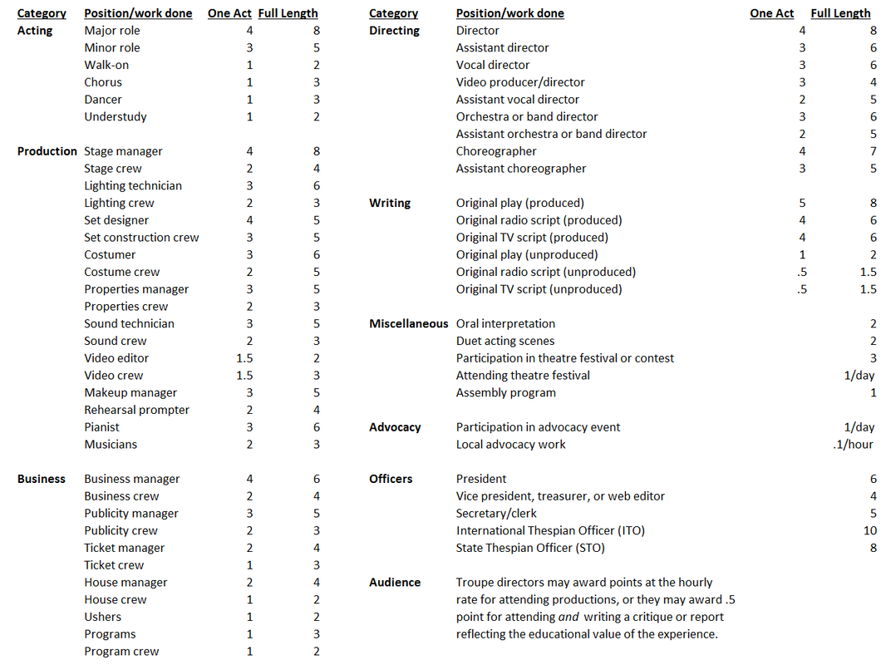
WAYS TO EARN POINTS

-

- Paint Crew is considered set construction crew.

OTHER WAYS TO EARN POINTS

Homecoming Float Decorating: ½ pt/hr
Homecoming Parade: 1 pt
Spirit Week: ½ pt/Dress Up Day
Attendance of Fine Arts Concert/Event (Including band halftime show): ½ pt
Extra in a major film/tv show: ½ pt/day
Actor in a major film/tv show (speaking): 3 pts
Short Film Director: 4 pts
Short Film Writer: 4 pts
Short Film Actor, Major Role: 3 pts
Short Film Actor, Supporting Role: 2 pts
Short Film Actor, Extra: 1 pt
Short Film Crew: 3 pts
Shuler Audience Member: 1 pt
Shuler Nominee: 1 pt/category
Shuler Honorable Mention: ½ pt/category
Shuler Winner: 4 pts/category
Shuler Performance: 2 pts
Shuler Ensemble: 2 pts
STAR Council: 2 pts
ThesCon Show Performance: 2 pts (for actors AND working technicians)
Chorus Concert (Performer): ½ pt National Anthem Performance: ½ Point
College Auditions: 1 pt per audition Thespian Outings/Fieldtrips : ½ pt
Instrumental Performance (Band/Orch) : ½ pt Talent Show Performance: ½ pt

GEORGIA THESPIAN CONFERENCE (THESCON)
WHAT IS THESCON?
Thespian Conference is a theatre festival held in Columbus, Ga for Georgia Thespians. Students participate in workshops, attend multiple shows, and attend/compete in competitions. There is a chance that our fall One Act (9 to 5) will perform at the conference.

WHERE IS IT?
Downtown Columbus, GA
(River Center for the Performing Arts/The Springer Opera House/Columbus State Theatre/Columbus Convention and Trade Center/One Arsenal Place)

Students are dropped off to the conference each morning by bus (Convention and Trade Center). From there, they will walk to workshops and shows. Thescon is a very secure conference with constant surveillance and security (Columbus PD and CSU PD). Students and chaperones will receive a badge that they must wear each day to be permitted in the conference.

**You can view last year’s schedule here.**

WHEN IS IT?
February 1-3, 2024

HOW MUCH DOES IT COST?
Cost for Students: $300
- $175 Registration
- $95 Hotel
- $5 Troupe Assessment Fee
- $25 Bus Rental Fee

Students should also prepare to bring spending money for extra food/souvenirs. The only meals not covered are lunch on the first day and dinner on the way back. Students may opt to not eat the conference food, as there are many restaurants in the downtown area.

Cost for Chaperones: $300
- $175 Registration
- $125 Hotel (Subject to change)

You are welcome to try and room with other chaperones, otherwise it is up to you to book your own room(s). I will be receiving a link for parents to use to access cheaper rates/be a part of our block.

**PAYMENT IN FULL IS DUE BY 12/1/23.**

There is an opportunity to receive a grant. See here: https://gathespians.org/sto/conference-grants/

You will need to get with Mrs.K if you would like to apply. We want you to be able to attend! Please try to apply first, and if you are denied we will reevaluate.

HOW DO I SIGN UP?
Please RSVP by 9/29/23 by clicking on the link below.
THESCON 2024
https://docs.google.com/forms/d/e/1FAIpQLSe41JvsUs_sMAXrmcOTNf1b4YhGpWipfG5OgJ_-gwaQa974tw/viewform?usp=sf_link
**You must turn in a COMPLETED conference agreement form to the RSVP link (above).
You can download the form here.**

Even if you change your mind, or THINK you might change your mind, please fill out the form and complete the agreement form. You have until 11/10/23 to change your mind, otherwise you will be expected to pay for Thescon IN FULL. This means, if you decide at the last minute not to attend, you will still be held responsible for paying. Failure to do so will result in the debt being passed to obligations with the administration.

GA THESPIANS WEBSITE: https://gathespians.org

SEASON AND SHOWS

This year’s season includes: 9 to 5: The Musical (One Act Play), Cinderella (Shuler Musical),
The Curious Incident of the Dog in the Nighttime (Spring Play).

AUDITIONS
9 to 5: The Musical: August 14 & 15 | sign up at smhstheatre.com

REHEARSAL DRIVE: https://drive.google.com/drive/folders/1pDz1qF9S8gGOJ0QL8vwvYWxu3rM1_KrO?usp=sharing

Cinderella: November 2 & 3 | sign ups will be available at smhstheatre.com
The Curious Incident…March 11 & 12 | sign ups will be available at smhstheatre.com

Please note that there is no guarantee that every student will be cast. EVERYONE will be given an opportunity to participate in some capacity, it just may not be on stage. We believe that technicians are just as important (if not more important) than those performing on stage.

Auditions are a very difficult process for the directors. Casting is the absolute worst part of the job. There are various pieces to the puzzle, and often casting results in the best arrangement of those pieces. This may even mean that the best singer/dancer/actor/etc may not be the “lead role”. It all just depends on how everything falls into place, and the best possible arrangement for the entire production. Please understand that we spend countless hours discussing and planning these cast lists. There will always be broken hearts, disappointments, and even anger no matter what happens during casing. Unfortunately, this is unavoidable. We wish we could give everyone the role they want.

During the audition process (auditions and callbacks), we tell each student to take 48 hours after the production list comes out to process and acknowledge their emotions. Some students will be defeated, upset, thrilled, or excited. The emotions will be everywhere, however; after 48 hours, we should find a neutral place to land. There is nothing more uncomfortable than a student that bashes other students/directors in front of everyone because they didn’t get the role they wanted. On the flip side, it is also uncomfortable when a student is braggy or overly excited because they got the role they did want. We ask for professionalism at all times.

REHEARSALS

Most rehearsals will be Mondays, Tuesdays, and Thursdays with an occasional Saturday as we get closer to the show. Please note that we are flexible, and can work with sharing your schedule with other extra-curricular activities, however; it is vital that you communicate your availability with Mrs.K prior to casting, as unapproved absences and lateness may result in your removal from the process.

Parents are expected to pick up their students on time. Student drivers that choose not to go home following rehearsal will be the responsibility of their parents. Directors are not to be held responsible for student drivers that do not immediately leave following rehearsal.

We will always allow students to leave at the time the schedule says. If we go over time, which is rare, they will be asked to text their guardians to let them know. Even if we go over time, they are allowed to leave when the schedule says. Mrs. K is always happy to confirm release time with parents and pull camera footage if need be.

TECH WEEK AND SHOW NIGHTS

Tech Week and Show Week are MANDATORY for every student involved, and for every production; UNLESS the absence/tardy is pre-approved by Mrs.K. This will be decided on a case by case basis (college auditions, family emergency, etc.) It is absolutely necessary for all pieces of the show (actors and technicians) to be present as it is a safety concern.

*NOT SHOWING UP TO A REHEARSAL DURING THESE TWO WEEKS WILL RESULT IN REMOVAL FROM THE SHOW. NO QUESTIONS ASKED.*

EXPECTATIONS AND RULES
- All school rules apply in rehearsals.
- We expect each student to show up prepared to each rehearsal they are called to.
- Gossip and nastiness towards other individuals will not be tolerated and will be immediately turned into administration.
- No student should give another actor or technician feedback, criticism, or notes unless specifically asked to do so by the directors.
- There shall be no screaming at actors by technicians or vice versa.
- Students are expected to clean up after themselves in every environment.
- Students will be held financially responsible for damaged materials and equipment.
- Hateful comments regarding SMHS (Faculty and Students) ,or SMHS THEATRE will not be tolerated (on social media or in person). If you hear someone constantly disparaging any of the above, please let us know.
- Please keep your hands to yourself. There are cameras in the auditorium, onstage, backstage, and in the audience. Do not do anything that you would not like your mother to watch via camera playback.
- Being upset after casting/tech assignments is completely normal. However, please remember that if your attitude interferes with the morale of the entire company, this is an issue.
- On the flip side, diva mentality will not be tolerated. All cast and crew members are equal. You are not better than anyone else on that stage or backstage. All parts are vital to the success of the production. Not just you.
- Be the reason that someone feels welcome and loved in our department. People may not remember the exact things you said to them or about them, but they will remember how you made them feel.
- Please wear appropriate clothing to rehearsals. Yoga pants, tshirts, sweats, clothes you can move in, are highly recommended. Wearing jeans, flip flops, constricting clothes, dresses, are not advised.
- NO ADMITTANCE TO THE TECH BOOTH without permission from the directors.
- Please stay in your assigned areas. (No mixing and mingling in other dressing rooms)
- All actors must wear unders (leotards, camisoles, spanx, gym shorts, tank tops) under costume
- There shall be no eating or drinking in costume other than water.
- Any destruction of provided costume may result in financial responsibility.
- No costume should be altered without permission from the director
- After casting, no actor may drastically alter their hair or appearance without talking with the director
- If it is not yours, do not touch it.
- When in doubt, ask. You cannot do/go wherever you want. Ultimately, your behavior reflects on yourself, your family, and directors. Think before you act.
- Please be considerate of your fellow cast and crew members. WEAR DEODORANT. Shower. Brush your teeth. Have good hygiene. We are all in close quarters.

DISCIPLINE
- Discipline will be handled as it is during school hours. Students will be corrected first by their directors. From there it becomes a disciplinary action with the administrators.
- Failure to communicate about absences or lateness will result in a discussion with directors. Lack of improvement will result in removal from the show
- Failure to maintain good personal hygiene will result in a letter home.
- Constant negativity and toxicity will be discussed with directors. Failure to improve will result in removal from the show.
- Sexual Misconduct will not be tolerated and will be an IMMEDIATE removal from the show.

TICKETS
ALL tickets for ALL shows will be sold online here. You can also go to our theater website (www.smhstheatre.com) and select the “TICKETS” tab.

You can purchase tickets with cash at the door, however, we will still have you select your seat(s). If at all possible, please purchase tickets ahead of time online. By doing so, we can quickly get you to your seats and start the performance on time.

**There are no fees for the patron when ordering online.**

GEORGIA HIGH SCHOOL MUSICAL THEATRE AWARDS (SHULERS)
Every year, we apply to be adjudicated by the Shuler Awards Committee.
Three judges come to watch our winter musical and rank us in various areas such as:
Ensemble, costuming, leading performers, supporting performers, featured performers, scenic design, lighting design, costume design, etc.

If we are nominated for OVERALL, we will be expected to rehearse for the full week leading up to the Shuler awards, where we will perform on stage at the Cobb Energy Center. These awards are featured on PBS.

If any student is nominated for Leading Actor or Leading Actress, they also perform in their own medley during the live show.

We will select Shuler Ensemble members as well as S.T.A.R council members that will also have obligations the week of the show. More information will be provided as we get closer.

There are many opportunities for scholarships! PLEASE take advantage of them.

More info here: https://artsbridgega.org/programs/shuler-awards/

FEES/DUES/PAYMENTS
Production Class Fee
Everyone is required to pay a $50 fee to be in this class. This fee will cover your T-Shirt, script, and your textbook (Audition by Michael Shurtleff.) It will also help pay for production costs. Think of this fee as the “Required Materials” section on a syllabus where you would then have to go out and purchase the items needed. We have found that if we handle the purchasing of items, we get exactly what we need/want for productions and the parents/students come out much cheaper.
*Since this class is audition based, everyone in Production Class will be a part of the show.*

Pay In Full by: 11/1/2023 ($50)
*Note that there will be a $25 late fee for late payments after 11/1/2023.*

One Act Fee (9 to 5)
The fee for actors in this production will be $300. The fee for technicians is $75.
If you are an actor and have a sibling that is ALSO an actor, the fees are: $300/1st child and $100/2nd child. If you are a- run crew technician, and you have a sibling that is a run crew technician, the fee is $75/1st Child and $25/2nd Child.

This fee covers production costs, as well as the t-shirt. You will be able to purchase additional shirts by filling out this form by 9/29/2023.

Pay In Full: 10/6/2023 ($300/$75)
*Note that there will be a $25 late fee for late payments.*

Shuler Musical Fee (Cinderella)
The fee for actors in this production will be $250. The fee for technicians is $75.
This fee covers production costs, as well as the t-shirt..
Pay In Full: 1/12/2024 ($250/$75)
*Note that there will be a $25 late fee for late payments.*
PHYSICAL ADS ARE DUE BY 2/9/24 (Meaning, the artwork/logo for the playbill)

Thescon
Pay In Full: 12/1/2023 ($300)
*Note that there will be a $25 late fee for late payments.

EVENTS AND FIELD TRIPS
A CHRISTMAS CAROL
Where: Alliance Theatre
When: December, 2023// Exact Date TBD

ANNUAL TYA PERFORMANCES
Where: Willie Duke Auditorium
When: Exact Date TBD

REGION ONE ACT COMPETITION
Where: Troup County High School
When: October 26th, 2023 (During the school day)

STATE ONE ACT COMPETITION
Where: Tift County High School
When: November 11th, 2023

GA THESPIAN CONFERENCE
Where: Downtown Columbus, Ga
When: February 1st-3rd, 2024

THE SHULER AWARDS
Where: Cobb Energy Center
When: April 18th, 2024

SPONSORSHIPS AND DONORS
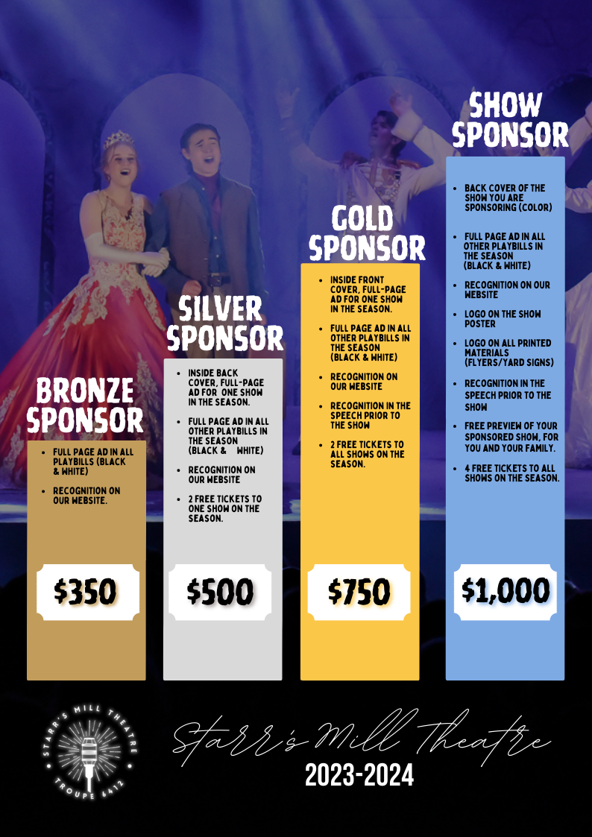

SHOUT OUTS AND ADS (RECEIPT/FORM)

Starting in the 2023-2024 season, we will have SHOUT OUTS AND ADS on the screens. Instead of putting ads in the playbill to cover production costs, we will have them mixed in with the one line shout outs before the show. We will also have a landing page for all ads via QR code. This will allow us to keep playbill costs down, while still giving you the option to cover fees via ads.

Shout Outs are remaining $20/each but Ads are changing to $50 a piece.
You are responsible for filling out the google form with all of the info needed. This form will be included in the welcome correspondence for each production.

NEW THIS YEAR: the shout outs can go toward your fees!

*There is a receipt on the next page that you can print to give to the business that purchases an ad.*

SENIOR ADS
Senior Ads for the Playbills can be purchased throughout the year. All ads must be submitted and paid by September 22nd to be included in our One Act Playbills. This ad will be in ALL playbills for Mainstage Productions (9 to 5, Cinderella, Curious Incident, Production Class). Purchase your SENIOR AD by 9/22/2023 to save $$.

FULL PAGE B&W
- $200 until Sept 22nd ($225 after)

HALF PAGE B&W
- $125 until Sept 22nd ($150 after)
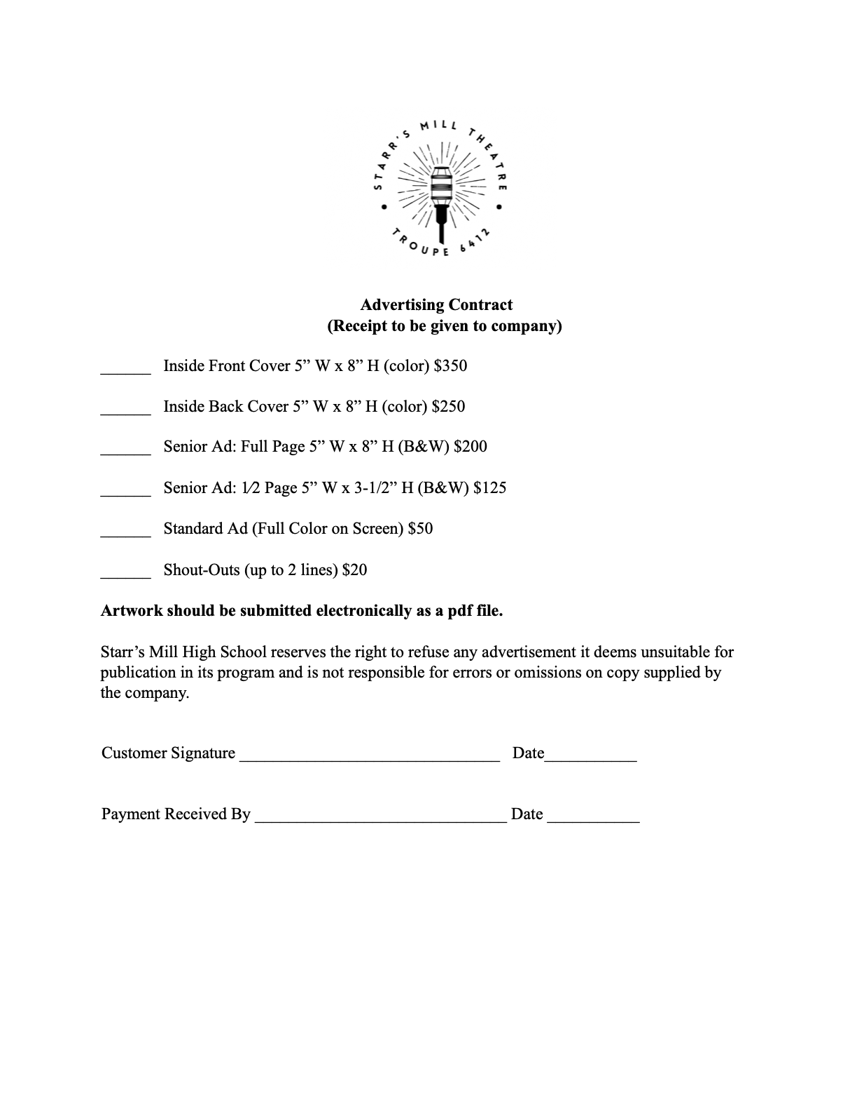
Student Name: _________________________________________________
Business Name:________________________________________________

TECHNICAL THEATRE PERMISSION SLIP
https://docs.google.com/document/d/102T0CpFNjTNm7WzZnH4JSm9A6IJZyHYwDWg9e3cFZLI/edit

PARENT BOOSTER CLUB (SMP)
INFO GOES HERE

THEATRE LINGO
COMPANY: The entire cast/crew for a show
LOAD IN: The rehearsal in which we put together the set on the stage and prepare for the tech/dress rehearsals
STRIKE: The removal and cleaning of the set/costumes/tech after the show
DRESS REHEARSAL: Rehearsal in which we run the show in true show conditions with full costume and hair.
CUE TO CUE: Rehearsal in which we go scene to scene to test lighting, sound, set changes, and spacing
BLOCKING: Positions and movement given to the actors by the director
SITZPROBE: Rehearsal in which actors sing through the show for the first time, usually with an orchestra or band
READ THRU: First time reading through the script as a company
ENSEMBLE: Those that help create the world of the play. They usually perform in group numbers, and though they do not usually have solo lines, they provide the context
STUMBLE THRU: The first time the company runs the show from start to finish
NOTES: At the end of every rehearsal, the director gives feedback to the actors and technicians
OPENING: First night of a performance
CLOSING: Last night of a performance
RUN CREW: Group of technicians that help run a show: spotlight operators, light/sound board operators, dressers, set movers

